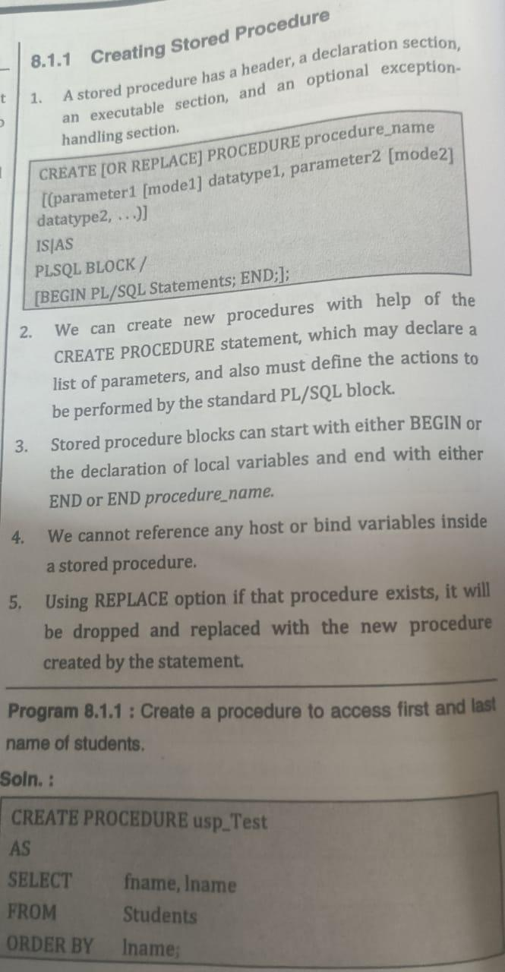

**1] Simple Procedure displaying Message**

delimiter $$

drop procedure if exists display$$

create procedure display()

begin

select "My first program" as "Output";

end $$

delimiter ;

* When **you write an individual statement you will need only a semicolon** at the end of the statement.
* But what **if you want to write a block of statements that works as a single unit**? **In that case, you will need to change the delimiter.**
* In MySQL, **stored procedures, functions and triggers are the blocks of statements** where you need the delimiter other than the default semicolon. **The delimiter helps MySQL to acknowledge the group of statements as a single unit or single task.** However, **the individual statements in the blocks end with semicolons.**
* If you are considering multiple statements, then **you need to use different delimiters like $$ or //.**

**2] Procedure to display value of variable**

delimiter $$

drop procedure if exists display$$

create procedure display()

begin

declare X int;

set X=10;

select X;

end $$

**3] Procedure to display addition of two numbers**

Delimiter $$

Drop procedure if exists addition$$

Create procedure addition()

Begin

Declare a,b ,c int;

Set a=10;

Set b=10;

Set C=a+b;

Select c;

End $$

**4] Procedure to display all records of table**

delimiter $$

drop procedure if exists faculty_display $$

create procedure faculty_display()

begin

select * from faculty ;

end $$

delimiter ;

**5]** **Procedure to display particular record of table through parameter passing**

delimiter $$

drop procedure if exists emp_display $$

create procedure emp_display (IN X int)

begin

select * from emp where emp_id =X ;

end $$

delimiter ;

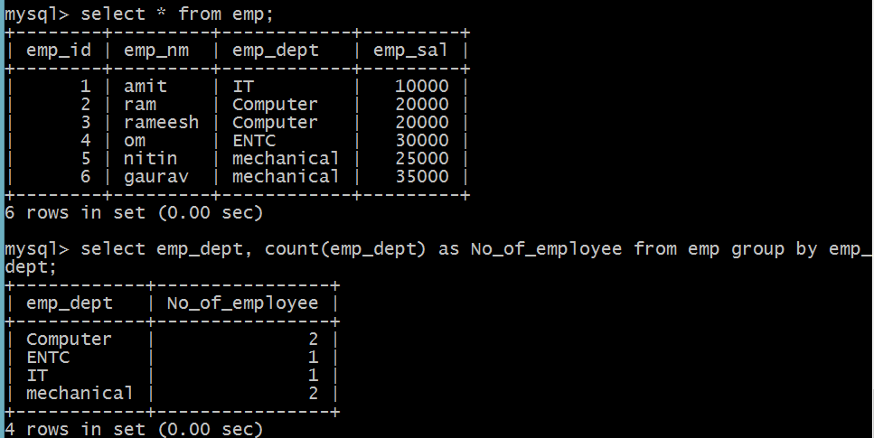

**6] Procedure to display NO.of employees through procedure**

delimiter $$

drop procedure if exists display $$

create procedure display (OUT cnt int)

begin

select count(emp_nm) as no_of_Employees from emp where emp_nm in(select distinct emp_nm from emp);

end $$

delimiter ;

**setp1 : execute this procedure**

**step 2: call the procedure in bracket specify @ sign with any parameter name . For example:call display(@a);**

**step 3: if does not get outout then use query as select name of parameter For ex: select a**

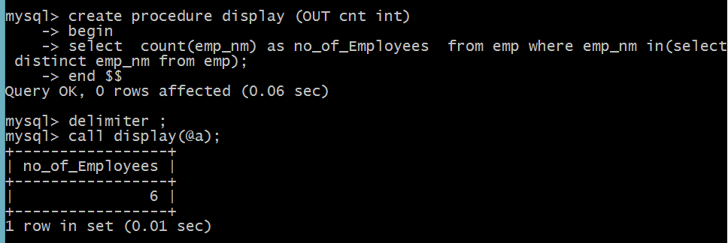

**7] Procedure to display NO.of different departments through procedure**

delimiter $$

drop procedure if exists display $$

create procedure display (OUT cnt int)

begin

select count(distinct emp_dept)as no_of_department from emp;

end $$

delimiter ;

